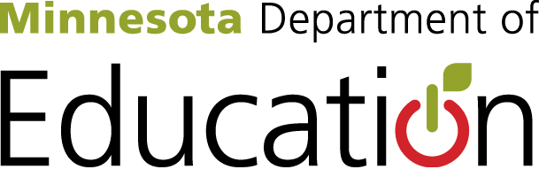
World’s Best Workforce Report Summary
In accordance with 2013 Minnesota Statutes, section 120B.11, a school board, at a public meeting, shall adopt a comprehensive, long-term strategic plan to support and improve teaching and learning that is aligned with creating the world's best workforce. The school board must transmit an electronic summary of its annual report to the commissioner of the Minnesota Department of Education each fall.

The report summary must include:
- A summary of progress toward improving teaching and learning and striving for the world’s best workforce (specifically, progress toward closing the achievement gap); all students ready for kindergarten; all students in third grade achieving grade-level literacy; all students attaining career and college readiness before graduating from high school; and all students graduating from high school.

- Information about best practice strategies that were implemented and that are showing evidence of impacting closing the achievement gaps and working toward creating the world’s best workforce in Minnesota.

While districts have significant flexibility in the development and format of the plan and report that is developed, this document is provided as guidance in response to district requests for a template for the report summary. Use of this format is optional. As you enter information into each section, the document will expand to accommodate your text.

Identified Needs Based on Data
[Note: Data that was reviewed to determine needs may include state-level accountability tests, such as Minnesota Comprehensive Assessments (MCAs) and/or local-level data, such as the Northwest Evaluation Association (NWEA) assessments.]
- List and describe the district’s identified needs, and the data each need was based upon here.

Support Category
Students
- Describe the support being offered to students to meet the goals here.

Teachers and Principals
- Describe the support being offered to teachers and principals to meet the goals here.

Systemic, Building or District
- Describe the support being offered at the systemic or district level to meet the goals here.

Best Practice Strategies and Action Steps
- Describe district strategies and action steps incorporated to address student achievement goals here.

Current Student Achievement Plans
[Note: Plans may include PBIS, Local Literacy Plan, Title 1, School Readiness Program Plan, Student Transition Plan to College and Career Readiness, Alternative Delivery of Specialized Instructional Services, Q Comp, Educator Evolution, Principal Evaluation, Title II Professional Development, School Improvement Plan, Continuous Improvement Monitoring Progress Plan, Integration Plan]
- Describe current student achievement plans here.
Key Indicators of Implementation Progress (implementation and/or outcome data)
[Note: Indicators may be implementation or process oriented and/or quantitative in nature.]
- List and describe key indicators of progress here.

Broad Outcomes Impacted
[Note: Goals should be linked to needs and written in SMART-goal format. Summary must include all areas listed below.]
All Students Ready for Kindergarten
- Describe the established goals and results in ensuring all students are ready for kindergarten here.
All Students in Third Grade Achieving Grade-Level Literacy
- Describe your established goals and results toward having all students in third grade achieving grade-level literacy here.
Closing Achievement Gap(s)
- Describe your established goals and results in closing the identified achievement gap(s) in your district here.
All Students Career- and College-Ready by Graduation
- Describe your established goals and results in ensuring all students are career- and college-ready before graduating from high school here.
All Students Graduate
- Describe your established goals and results toward all students graduating from high school here.

